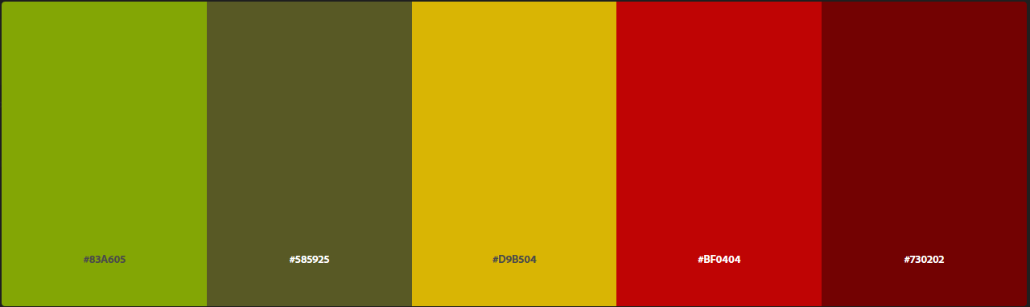

This is the color pallet I decided to use for my Capstone project client “Urban Gardens.” I chose this color pallet because I wanted to show the connection between mans Urban development and natures earthy tones. Which led me to these darker colors which can be found in a city or the forest beside it.

* #83A605 – Apple Green – Growth, Harmony, and Kindness – I want to harmonize the connection between people and nature.
* #585925 – Dark Moss Green – Safety, Stability, reliability – I want to ensure people of the reliability of the services offered by Urban Gardens.
* #D9B504 – Harvest Gold – Loyal, Dependable, and Prepared – I want people to know that Urban Gardens is loyal to all its Customers and can handle any challenge.
* #BF0404 – Boston University Red – Excitement, Energy, and Attention – Urban Gardens will work on your projects with energy and pay great attention to detail.
* 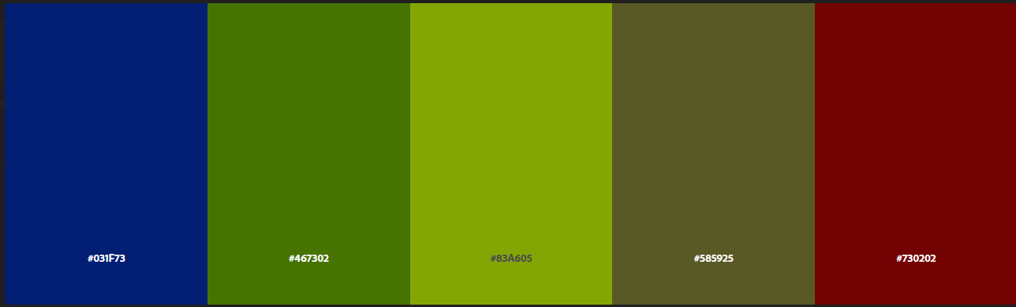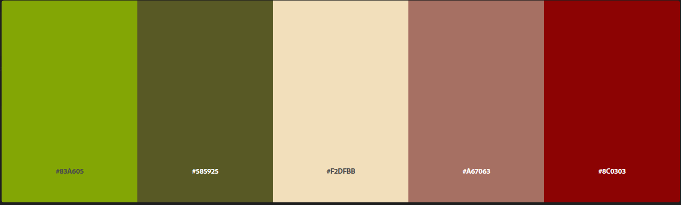#730202 – Maroon (HTML, CSS) – Confidence, Creativity, and strength – Urban gardens is confident in their creative projects and will always achieve great results.